**BANNER , FILYERS , BASIC OF SERVICE NOW**

1. **Modify your instance name to personalise banner text and add a custom banner image(logo)**

Go to System properties

Basic Configuration UI16 and change the field:

Then you can update all the properties you need.

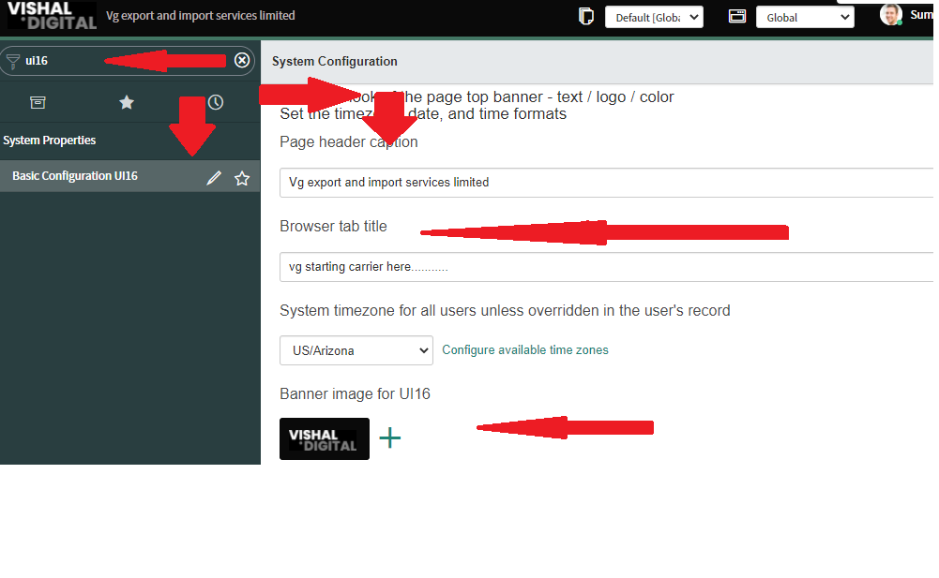

**2. Personalise Banner Text and Banner Image(Logo)**

**image(logo)**

Go to System properties

Basic Configuration UI16 and change the field:

Then Personalise Banner Text and Banner Image(Logo)

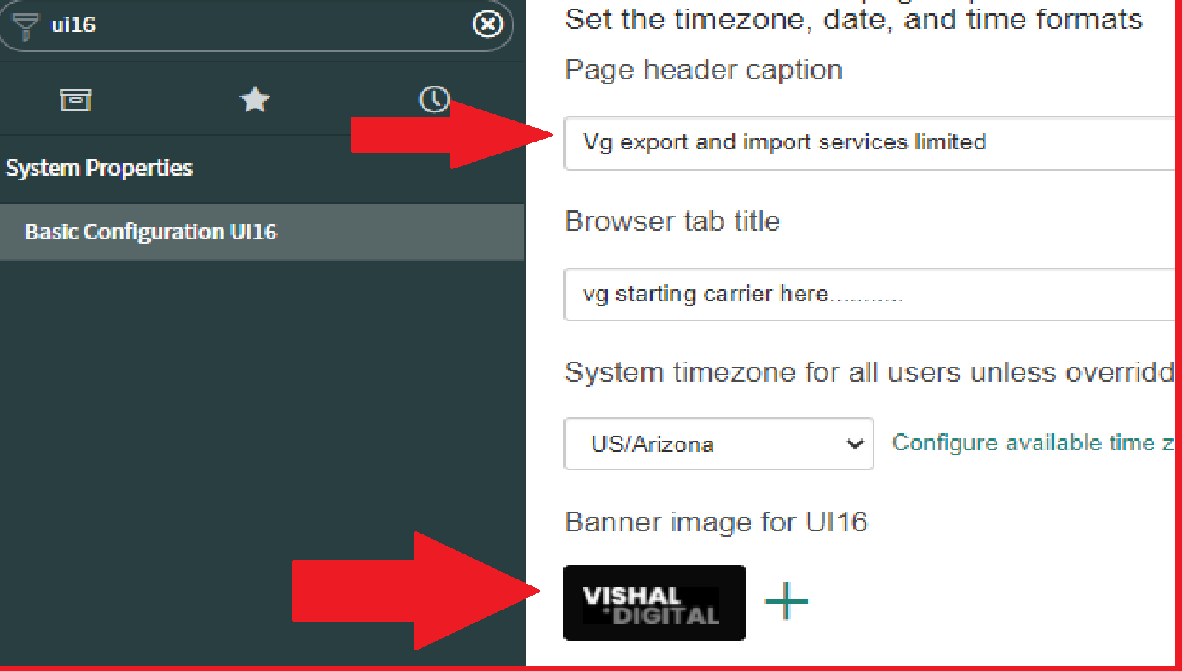

**3. Manage and personalise Lists and form for Incident, Problem, and Change**

**Personalize list**

Go to System properties

Then open incident table

And go to the left side gear icon and (personalize list)

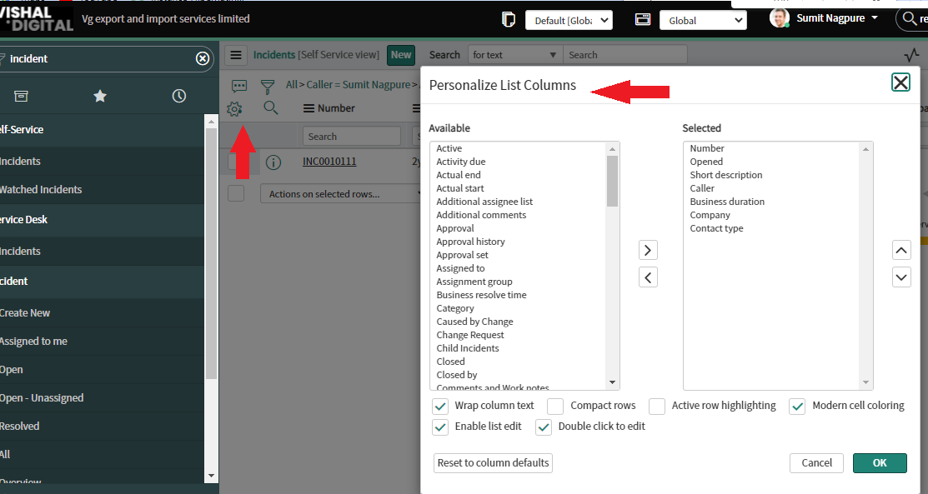

**List...**

Go to System properties

Then open incident table go to list

**It displays the set of records (based on certain conditions) from the data table. It could be a list of incidents assigned to a certain group, from the incident table or list of problems not assigned to any group from problem table, etc. Below is an example, of the Incident list having incidents, which are resolved from the incident table**

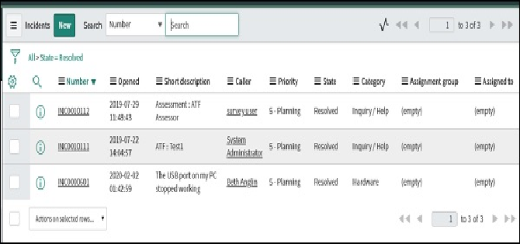

**Form...**

Go to System properties

Then open incident table go to Form

**an incident form will display details related to a single selected incident or it can also be used to enter details of a new incident in an incident table. The form which have details of existing incident record and form to enter the details of the new incident record are given below respectively**

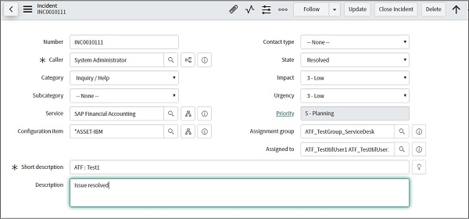

**Problem**

Go to System properties

Navigate to Problem >

Create New. Open the incident

Create a problem

**You can generate a problem record manually from the problem module. You can generate a problem from an incident. You can create a record producer to log problems from the service catalog.**

**\**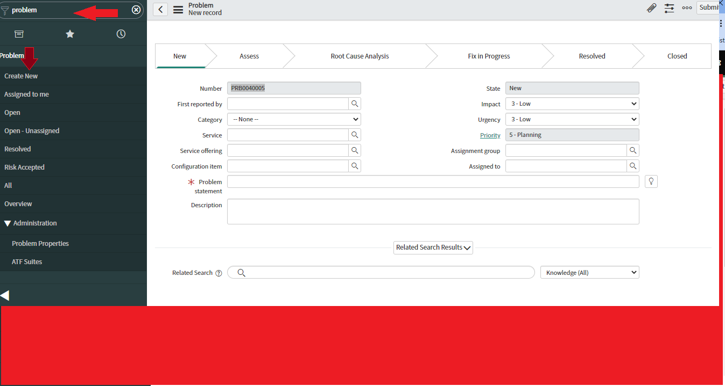

**4. Create & Apply Filters**

Go to System properties

Open incident table

Then click on funnel icon

Choose the filter or apply condition

Save the filter then

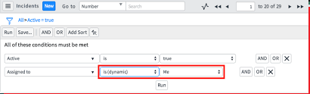

Then Click on hamburger icon >filter>filter name

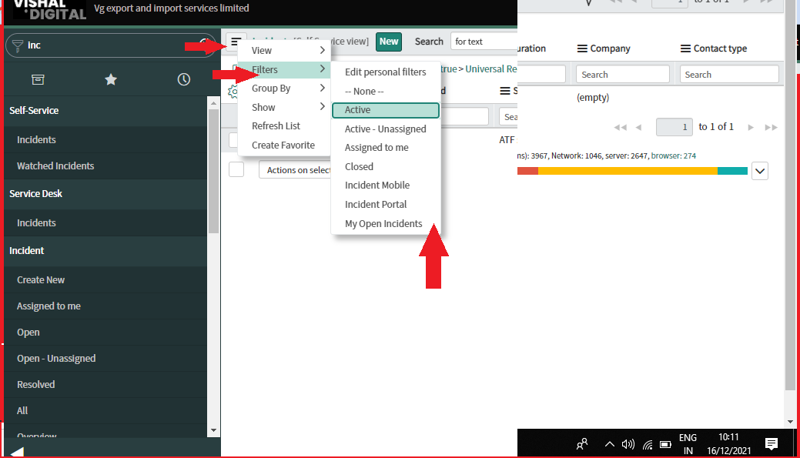

**5. Group the category column**

Go to System properties

Open incident table

In context menu category hamburger icon

Go to group by category name

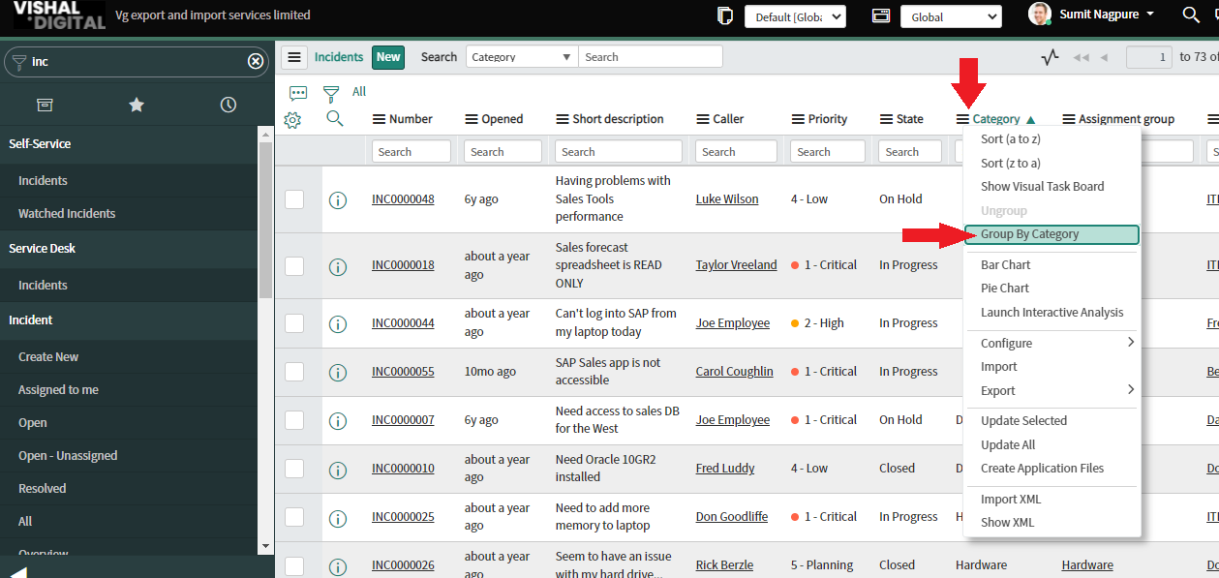

**6. Open table in list view Url**

Go to System properties

Open incident with example 1

Right click on ticket on incident number then

Copy sys id

https://<baseURL>/nav_to.do?uri=sys_user_list.do

**7. What are the various ways to get sys_id**

Go to System properties

Open incident table

Right click on ticket on incident number then

Copy sys id

**Using list view...**

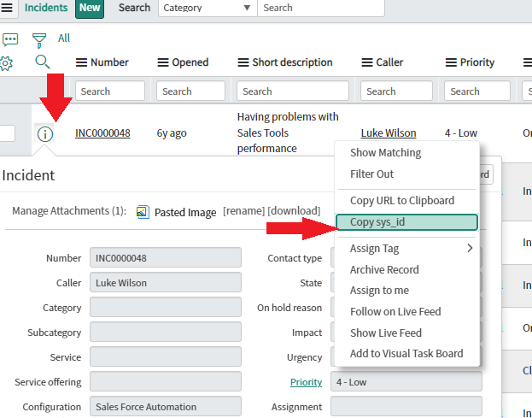

**Using form view...**

